- The Neutrality Acts of 1935–1937 were primarily
designed to
(1) avoid policies that had led to United States
involvement in World War I
(2) halt the spread of communism in theWestern
Hemisphere
(3) promote United States membership in the
League of Nations
(4) stop Japan from attacking United States
territories in the Far East
- In Korematsu v. United States (1944), the
Supreme Court said that the removal of Japanese
Americans from their homes was constitutional
because
(1) most Japanese Americans were not United
States citizens
(2) many Japanese Americans refused to serve in
the United States Armed Forces
(3) this type of action was necessary during a
national emergency
(4) there was strong evidence of significant
Japanese sabotage on the West Coast
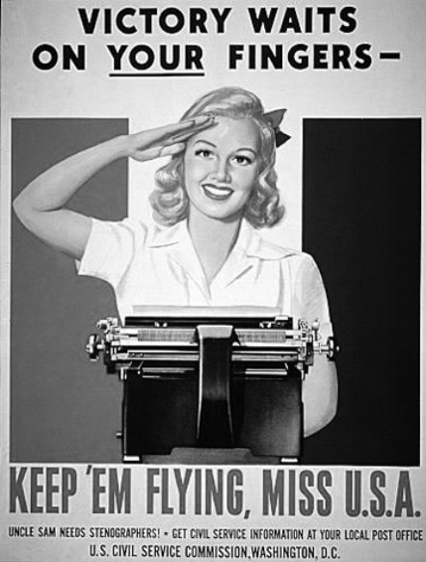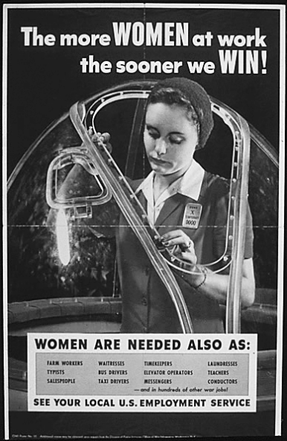
3. These posters were used during World War II to encourage women to
(1) serve in the armed forces (3) buy war bonds
(2) exercise their vote (4) contribute to the war effort

- Which statement best explains why the United
States mainland suffered minimal physical
damage in both World War I and World War II?
(1) The United States policy of isolationism
discouraged attacks by other countries.
(2) Geographic location kept the United States
protected from most of the fighting.
(3) United States military fortifications
prevented attacks on United States soil.
(4) Latin America provided a buffer zone from
acts of aggression by other countries.
- In which pair of events is the second event a
response to the first?
(1) Truman Doctrine → D-Day Invasion
(2) Manhattan Project → Lend-Lease Act
(3) Holocaust → Nuremberg War Crimes trials
(4) Germany’s invasion of Poland → Munich
Conference
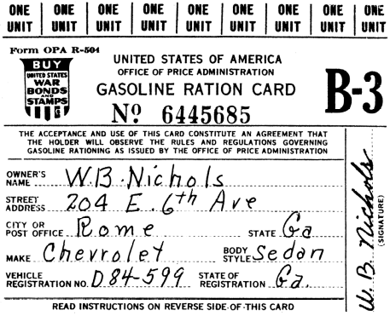
- The use of this card, issued by the federal
government, was intended to
(1) help the automobile industry
(2) support the troops in wartime
(3) increase the use of gasoline
(4) decrease the cost of automobiles

“Arms Sales to Warring Nations Banned”
“Americans Forbidden to Travel on Ships of Warring
Nations”
“Loans to Nations at War Forbidden”
“War Materials Sold Only on Cash-and-Carry Basis”

- These headlines from the 1930s reflect the efforts
of the United States to
(1) maintain freedom of the seas
(2) send military supplies to the League of
Nations
(3) limit the spread of international communism
(4) avoid participation in European wars
8. A main purpose of government-ordered rationing
during World War II was to
(1) increase foreign trade
(2) limit the growth of industry
(3) conserve raw materials for the war effort
(4) encourage women to enter the workforce
“. . . The Director of the War Relocation Authority
is authorized and directed to formulate and
effectuate [implement] a program for the
removal, from the areas designated from time to
time by the Secretary of War or appropriate
military commander under the authority of
Executive Order No. 9066 of February 19, 1942,
of the persons or classes of persons designated
under such Executive Order, and for their
relocation, maintenance, and supervision. . . .”
— Executive Order 9102, March 18, 1942

- Shortly after this executive order was signed,
federal government authorities began to
(1) move Japanese Americans to internment
camps
(2) deport German and Italian aliens
(3) detain and interrogate Chinese immigrants
(4) arrest the individuals who planned the attack
on Pearl Harbor

“. . . The people of Europe who are defending
themselves do not ask us to do their fighting.
They ask us for the implements of war, the
planes, the tanks, the guns, the freighters which
will enable them to fight for their liberty and for
our security. Emphatically we must get these
weapons to them, get them to them in sufficient
volume and quickly enough, so that we and our
children will be saved the agony and suffering of
war which others have had to endure. . . .”
— President Franklin D. Roosevelt’s “Fireside Chat,”
December 29, 1940

In this statement, President Franklin D.
Roosevelt was asking the nation to
(1) support a declaration of war against Nazi
Germany
(2) adopt a policy of containment
(3) join the League of Nations
(4) become the “arsenal of democracy”
Which factor contributed to the internment of
Japanese Americans during World War II?
(1) labor shortage during the war
(2) influence of racial prejudice
(3) increase of terrorist activities on the West
Coast
(4) fear of loss of jobs to Japanese workers
At the beginning of World War II, national
debate focused on whether the United States
should continue the policy of
(1) coexistence (3) imperialism
(2) containment (4) isolationism

Before entering World War II, the United States
acted as the “arsenal of democracy” by
(1) creating a weapons stockpile for use after the
war
(2) financing overseas radio broadcasts in
support of democracy
(3) providing workers for overseas factories
(4) supplying war materials to the Allies

Which wartime policy toward Japanese
Americans was upheld by the Supreme Court in
its 1944 ruling in Korematsu v. United States?
(1) deportation to Japan
(2) mandatory military service
(3) denial of voting rights
(4) confinement in internment camps

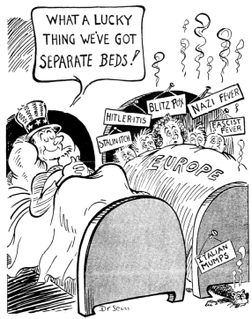Ho Hum! No Chance of Contagion

In the cartoon, most of the “diseases” refer to the
(1) military dictatorships of the 1930s
(2) Allied powers of World War II
(3) nations banned from the United Nations after
World War II
(4) Communist bloc countries in the Cold War

Which action is most closely associated with the
situation shown in the cartoon?
(1) signing of the Atlantic Charter
(2) passage of the Neutrality Acts of 1935–1937
(3) first fireside chat of Franklin D. Roosevelt
(4) declaration of war on Japan

The Neutrality Acts passed by Congress in the
mid-1930s were efforts to
(1) avoid mistakes that led the country into
World War I
(2) create jobs for the unemployed in the military
defense industry
(3) support the League of Nations efforts to stop
wars in Africa and Asia
(4) help the democratic nations of Europe
against Hitler and Mussolini

The decision of the Supreme Court in Korematsu
v. United States (1944) upheld the power of the
president during wartime to
(1) ban terrorists from entering the country
(2) limit a group’s civil liberties
(3) stop mistreatment of resident legal aliens
(4) deport persons who work for enemy nations

Why was the United States called the “arsenal of
democracy” in 1940?
(1) The leaders in the democratic nations of
Europe were educated in the United States.
(2) Most of the battles to defend worldwide
democracy took place on American soil.
(3) The United States supervised elections in
European nations before the war.
(4) The United States provided much of the
weaponry needed to fight the Axis powers.

Shortly after entering World War II, the United
States began the Manhattan Project to
(1) work on the development of an atomic bomb
(2) increase economic production to meet
wartime demands
(3) defend New York City against a nuclear
attack
(4) recruit men for the military services

A primary objective of United States foreign
policy during the 1930s was to
(1) avoid involvement in Asian and European
conflicts
(2) protect business interests in Africa through
direct intervention
(3) strengthen international peacekeeping organizations
(4) acquire overseas land as colonies

During World War II, many Japanese Americans
living on the West Coast were relocated to
detention centers primarily because they
(1) were known spies for Japan
(2) were seen as a security threat
(3) refused to serve in the United States military
(4) expressed their support for Italy and
Germany

To help pay for World War II, the United States
government relied heavily on the
(1) money borrowed from foreign governments
(2) sale of war bonds
(3) sale of United States manufactured goods to
neutral nations
(4) printing of additional paper money

In the 1930s, Congress attempted to avoid the
situations that led to United States involvement
in World War I by
(1) enacting a peacetime draft law
(2) passing a series of neutrality acts
(3) authorizing the deportation of American
Communist Party members
(4) relocating Japanese Americans to internment
Camps

During World War II, the federal government
used rationing to
(1) hold down prices of military weapons
(2) increase educational benefits for veterans
(3) increase imports of scarce products
(4) provide more resources for the military

Which federal policy was enacted during World
War II and justified as a wartime necessity?
(1) a ban on German-language books
(2) internment of Japanese Americans
(3) exclusion of Chinese immigrants
(4) adoption of the quota system of immigration

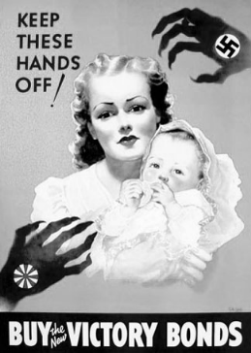
During World War II, this poster was used
primarily to
(1) contain the spread of communism
(2) create jobs for the unemployed
(3) gain financial support for the war
(4) convince women to fill vacant factory jobs

Between 1934 and 1937, Congress passed a series
of neutrality acts that were designed primarily to
(1) strengthen the nation’s military defenses
(2) provide aid to other democratic nations
(3) create jobs for unemployed American
workers
(4) avoid mistakes that had led to American
involvement in World War I

In the 1944 case Korematsu v. United States, the
Supreme Court ruled that wartime conditions
justified the
(1) use of women in military combat
(2) ban against strikes by workers
(3) limitations placed on civil liberties
(4) reduction in the powers of the president

During World War II, posters of Rosie the
Riveter were used to
(1) recruit women into wartime industries
(2) encourage women to serve in the armed forces
(3) promote women’s suffrage
(4) support higher education for women

What was one result of World War II?
(1) The arms race ended.
(2) The Cold War ended.
(3) Communism was eliminated.
(4) Two superpowers emerged

• Cash and Carry (1937)
• Destroyers for Naval Bases Deal (1940)
• Lend-Lease Act (1941)
Which change in United States foreign policy is
demonstrated by the passage of these acts prior
to World War II?
(1) a shift from neutrality toward more direct
involvement
(2) an effort to become more neutral
(3) a movement from isolationism to containment
of communism
(4) a desire to provide aid to both Allied and Axis
Powers

During World War II, many women experienced
a change in role in that they
(1) served in military combat positions
(2) worked in jobs formerly held by men
(3) controlled most corporations
(4) chaired several congressional committees

During the early years of World War II, the
Destroyer Deal and the Lend-Lease Act were
efforts by the United States to
(1) help the Allies without formally declaring war
(2) maintain strict neutrality toward the war
(3) negotiate a settlement of the war
(4) provide help to both sides in the war

Prior to United States entry into World War II,
Congress passed the Cash-and-Carry Act of 1939
and the Lend-Lease Act of 1941. These foreign
policy actions showed that the United States
(1) gave equal support to both the Allied and Axis
Powers
(2) attempted to contain the spread of communism
(3) maintained a strict policy of isolationism
(4) became increasingly drawn into the war in
Europe

“. . . it is known that there are Japanese residents
of California who have sought to aid the
Japanese enemy by way of communicating
information . . .”
— Culbert Olson, Governor of California,
February 1942

This statement helped influence President
Franklin D. Roosevelt to
(1) ask Congress to declare war on Japan
(2) force most Japanese Americans to leave the
United States
(3) send federal troops to guard California’s capital
(4) restrict the civil liberties of Japanese Americans

Which factor encouraged an American policy of
neutrality during the 1930s?
(1) disillusionment with World War I and its results
(2) decline in the military readiness of other nations
(3) repeal of Prohibition
(4) economic prosperity of the period

“Korematsu was not excluded from the military
area because of hostility to him or his
race. He was excluded because we are at war
with the Japanese Empire, because the . . .
authorities feared an invasion of our West
Coast and felt constrained to take proper
security measures.”
—Justice Hugo Black
Korematsu v. United States, 1944

Which generalization is supported by this quotation?
(1) Individual rights need to be maintained in
national emergencies.
(2) The Supreme Court lacks the power to block
presidential actions taken during wartime.
(3) Individual rights can be restricted under certain
circumstances.
(4) Only the Supreme Court can alter the constitutional
rights of American citizens.

Which statement identifies a change in American
society during World War II?
(1) Economic opportunities for women increased.
(2) Government regulation of the economy
decreased.
(3) The Great Depression worsened.
(4) Racial tensions were eliminated.

What was a key challenge faced by the United
States during World War II?
(1) lack of public support for the war effort
(2) fighting the war on several fronts
(3) difficulty gaining congressional support
(4) total reliance on naval power

World War I and World War II brought about
changes for minorities and women because these
conflicts led to
(1) the creation of new job opportunities
(2) the passage of the Equal Rights Amendment
(3) a greater number of high-level management
positions
(4) greater integration in housing and schools
throughout the nation

The United States Supreme Court decision in
Korematsu v. United States (1944) concerned
(1) restricting freedom of the press
(2) the president’s right to use atomic weapons
(3) limiting civil liberties during wartime
(4) the right of women to serve in military combat

The primary purpose of President Franklin D.
Roosevelt’s Good Neighbor policy was to
1 reduce United States military intervention in
Latin America
2 use United States troops to stop Axis aggression
in the Western Hemisphere
3 help Latin American nations combat the
effects of the Great Depression
4 repeal the principles of the original Monroe
Doctrine

Which statement describes a major social and
economic impact on American society during
World War II?
1 The Great Depression continued to worsen.
2 More women and minorities found employment
in factories.
3 The United States became an agricultural
society.
4 Consumer goods became easier to obtain.

A reason that President Harry Truman decided to
use atomic weapons against Japan was to
1 end the war while limiting the loss of American
lives
2 punish the Japanese people by destroying their
country
3 increase Japan’s potential as a future aggressor
4 divert forces to fight Germany

The election of Franklin D. Roosevelt to a third
term as President in 1940 was controversial primarily
because this action
1 upset the system of checks and balances
2 violated an amendment to the Constitution
3 challenged a long-held political tradition
4 interfered with the functioning of the electoral
College

The neutrality laws passed in the 1930’s were
based on the assumption that the surest way to
avoid war was for the United States to
1 maintain a superior army and navy
2 restrict loans to and limit trade with warring
nations
3 discourage aggressors by threatening military
reprisals
4 enter alliances with other democratic nations

