Review Questions on the Progressive Era
- In the late 1800s, rapid urbanization was mainly
the result of the
(1) shortage of land for new farms
(2) federally funded city redevelopment projects
(3) impact of industrialization
(4) migration of formerly enslaved persons to
the West

2. A major goal of the Sherman Antitrust Act was to
(1) prevent the formation of business monopolies
(2) limit imports from foreign nations
(3) set fair prices for manufactured goods
(4) protect consumers from dangerous products

- During the Progressive Era (1900–1920),
muckrakers were best known for
(1) forming new political parties
(2) organizing protest rallies and marches
(3) serving in Congress and state legislatures
(4) exposing harmful practices of business and
Government
- In 1892, the United States government opened
Ellis Island primarily to
(1) process immigrants arriving from overseas
(2) defend New York City from attack
(3) check the safety of imported products
(4) serve as the first federal prison in New York
State
- Progressive Era writers such as Upton Sinclair
and Ida Tarbell were called muckrakers because
they
(1) exposed corruption in business and government
(2) based their writings on unsupported opinions
(3) were members of political machines
(4) supported changes in farming methods

- Which event led to the passage of laws that
created safer working conditions?
(1) Haymarket riot
(2) Pullman strike
(3) Triangle Shirtwaist fire
(4) breakup of the Standard Oil Company
7. In the period from 1890 to 1910, most
immigrants from eastern and southern Europe
settled in large cities of the eastern United States
primarily because
(1) farmland had become very scarce
(2) factory jobs were available for unskilled
workers
(3) there was much less discrimination in those
cities
(4) they came mainly from large cities in their
home countries
- During the Progressive Era, many states began
to use primary elections to allow voters to
(1) remove elected officials from their offices
(2) petition their elected representatives to
pass laws
(3) choose party candidates for elected offices
(4) express their views on proposed new laws

- The cartoonist pictures President Theodore
Roosevelt’s approach to governing as
(1) blending several different political ideas
(2) favoring conservative views over other
approaches
(3) stirring up outdated practices
(4) supporting the interests of the wealthy

- “Give me your tired, your poor,
Your huddled masses yearning to breathe free,
The wretched refuse of your teeming shore.
Send these, the homeless, tempest-tost, to me,
I lift my lamp beside the golden door!”
— Emma Lazarus

The main message of this poem was to
(1) encourage a back-to-Africa movement
among freed slaves
(2) call for the imprisonment of illegal immigrants
(3) welcome new immigrants to the United
States
(4) support the quota system placed on immigrants

- Muckrakers were writers and critics of the early
1900s who wanted to
(1) expose corruption and abuses in industry
(2) put an end to immigration
(3) prevent integration in cities
(4) shut down all factories and industries

- During the last quarter of the 19th century, large
numbers of immigrants were admitted to the
United States primarily because of the economy’s
need for more
(1) skilled craftsmen
(2) educated professionals
(3) unskilled factory workers
(4) scientists and technicians

- A major purpose of both the Chinese Exclusion
Act (1882) and the Gentlemen’s Agreement with
Japan (1907) was to
(1) limit immigration of certain ethnic groups
(2) enrich America’s cultural diversity
(3) treat all Asian and European immigrants
equally
(4) relocate Asians displaced by war

- In his book, How the Other Half Lives,
muckraker Jacob Riis exposed the
(1) ruthlessness of the Standard Oil Company
(2) social ills of life in New York City’s tenements
(3) unsanitary conditions in the meatpacking
industry
(4) abuses of the railroad industry

- What was a major reason most western states
granted women suffrage prior to the adoption of
the 19th amendment?
(1) Western states had more college-educated
women than the eastern states.
(2) Women outnumbered men in states west of
the Mississippi River.
(3) A majority of western states had legislatures
controlled by women.
(4) The important roles played by frontier
women promoted equality.

- Progressive Era reformers sought to expand voter
participation in government by adopting
(1) the initiative and referendum
(2) tougher literacy tests
(3) additional poll taxes
(4) a civil service system

- What was the goal of those who supported the
constitutional amendment that provided for
direct election of United States senators?
(1) expanding the power of the legislative branch
(2) providing equal voting rights to minority
groups
(3) making the Senate more responsive to the
people
(4) basing Senate representation on state
population

- The national income tax, free and unlimited
coinage of silver, and the direct election of
senators were proposals that were included in the
(1) Declaration of Sentiments
(2) Republican plan for Reconstruction
(3) Populist Party platform
(4) Federal Reserve System

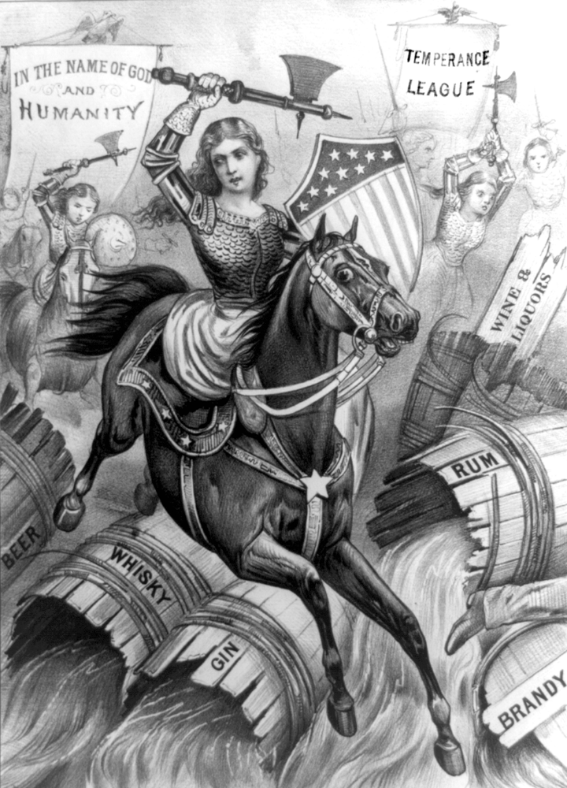
- The “Holy War” illustrated in the cartoon was an
effort to
(1) recruit women soldiers
(2) promote world peace
(3) ban the sale of alcoholic beverages
(4) spread Christian religious beliefs

- Women gained a victory in the “war” shown in the
cartoon through the
(1) ratification of a constitutional amendment
(2) legalization of birth control
(3) expansion of missionary activities overseas
(4) repeal of national Prohibition

Base your answers to questions 20 and 21 on the
statements below that discuss immigration laws in
the early 20th century, and on your knowledge of
social studies.

Speaker A: A literacy test as a requirement for
immigration to the United States is
reasonable. Great numbers of uneducated
workers take jobs and good wages from our
workers.
Speaker B: Requiring literacy of immigrants is
unfair. It will keep people out because
they lacked the opportunity to gain an
education.
Speaker C: A literacy test will allow more people
from northern and western Europe to
enter. They are similar to the majority of
the United States population.
Speaker D: Literacy is not an issue. The real
purpose of this law is to discriminate
against immigrants from certain parts of
the world.

- Supporters of literacy tests to restrict immigration
would most likely favor the views of
Speakers
(1) A and C (3) B and D
(2) B and C (4) A and B

21. The immigrants referred to by Speaker D were
mainly from
(1) Canada and Mexico
(2) South America
(3) western Europe
(4) southern and eastern Europe

22. During the Progressive Era, public demands for
direct consumer protection resulted in passage of
the
(1) Pure Food and Drug Act
(2) Fair Labor Standards Act
(3) Underwood Tariff
(4) income tax amendment

23. The Federal Reserve System helps to regulate
(1) the annual federal budget
(2) state sales tax rates
(3) Social Security payments
(4) the nation’s money supply

24. In 1906, the publication of The Jungle, written by
Upton Sinclair, led Congress to
(1) enact stronger prohibition laws
(2) support the national conservation movement
(3) establish a system for meat inspection
(4) legalize strikes and boycotts by labor unions

25. During the late 1800s, many farmers supported
the idea that free and unlimited coinage of silver
would
(1) end farm subsidies
(2) help farmers to repay their loans
(3) lead to lower prices for consumer goods
(4) decrease prices for farmland

26. Which term best describes Theodore Roosevelt,
John Muir, and Gifford Pinchot?
(1) philanthropists
(2) conservationists
(3) yellow journalists
(4) captains of industry

27. During the Progressive Era, many state and local
governments adopted initiative, referendum, and
recall procedures that
(1) eliminated the need for the electoral college
(2) created political action committees (PACs)
(3) gave voters a more direct voice in government
(4) strengthened the role of the president’s
cabinet

28. The tragedy of the Triangle Shirtwaist Company
fire of 1911 drew national attention to the need to
(1) restrict immigration from southern Europe
(2) establish full-time fire departments
(3) protect the safety of workers
(4) improve conditions for tenement dwellers

29. A goal of the Progressive movement was to
(1) reduce the government’s involvement in
social issues
(2) correct the problems caused by
industrialization
(3) promote laissez-faire policies
(4) promote settlement of land west of the
Mississippi River

30. The Interstate Commerce Act and the Sherman
Antitrust Act were attempts by Congress to
(1) regulate the activities of big business
(2) protect consumers against unsafe products
(3) impose government regulations on agricultural
production
(4) bring transportation activities under government
Ownership

31. The “new immigrants” to the United States
between 1890 and 1915 came primarily from
(1) southern and eastern Europe
(2) northern and western Europe
(3) East Asia
(4) Latin America

32. Both the Interstate Commerce Act and the
Sherman Antitrust Act were
(1) inspired by the effectiveness of earlier state
laws
(2) designed to protect business from foreign
competition
(3) declared unconstitutional by the Supreme
Court in the late 1800s
(4) passed by the federal government to regulate
big business

33. During the Progressive Era, muckrakers published
articles and novels primarily to
(1) advance their own political careers
(2) make Americans aware of problems in society
(3) help the federal government become more
efficient
(4) provide entertainment for readers

34. Supporters of a graduated national income tax
argued that it was the fairest type of tax because
the
(1) rate of taxation was the same for all persons
(2) rate of taxation increased as incomes rose
(3) income tax provided the most revenue for the
government
(4) income tax replaced state and local
government taxes

35. During the late 1800s and early 1900s, where did
most of the immigrants to the United States
settle?
(1) urban centers of the Northeast
(2) plantations of the New South
(3) mining areas of the Far West
(4) farming regions of the Great Plains

36. Which reform idea was a common goal of the
Populists and the Progressives?
(1) restoration of the nation’s cities
(2) expansion of opportunities for immigrants
(3) improvement in the status of African
Americans
(4) greater control of government by the people

37. Jane Addams and Jacob Riis were most notable
for their efforts to
(1) treat the wounded in World War I
(2) stop the spread of diseases in Latin America
(3) legalize birth control for women
(4) aid the urban poor

38. The Federal Reserve System was created to
(1) maintain a national petroleum supply
(2) provide military support for the armed forces
(3) protect consumers from fraud
(4) manage the nation’s supply of currency and
interest rates

39. The Sherman Antitrust Act and the Clayton
Antitrust Act were passed in an effort to
(1) promote the formation of new trusts
(2) maintain competition in business
(3) increase business investment
(4) limit the activities of foreign corporations

40. The success of the Populist Party of the 1890s can
best be measured by which development?
(1) The party replaced one of the two major
parties.
(2) The party gained support among business
leaders.
(3) Two of the party’s candidates were elected to
the presidency.
(4) Several of the party’s proposed reforms were
made into laws.

41. During the Progressive Era, Jane Addams
responded to urban conditions by working to
establish
(1) settlement houses that provided assistance to
the poor
(2) newspapers that helped to inform Americans
about slum conditions
(3) laws that restricted certain immigrant groups
(4) free public schools located in inner-city
Neighborhoods

42. Which president was known as a trustbuster?
(1) George Washington
(2) Calvin Coolidge
(3) Theodore Roosevelt
(4) Dwight Eisenhower

43. President Woodrow Wilson supported creation of
the Federal Reserve System in 1913 to
(1) balance the federal budget
(2) regulate the amount of money in circulation
(3) serve as a source of loans for farmers
(4) solve the financial problems of the Great
Depression

44. Dorothea Dix, Jane Addams, and Jacob Riis were
all known as
(1) muckrakers (3) political leaders
(2) suffragettes (4) social reformers

45. Passage of the Pure Food and Drug Act and the
Meat Inspection Act illustrated the federal
government’s commitment to
(1) environmental conservation
(2) workers’ rights
(3) business competition
(4) consumer protection

46. Which conclusion can be drawn about the impact of the Populist and the Progressive parties on the United States?
 | 1. | Some third-party goals eventually become planks in the platforms of the major parties.
 | 2. | The United States has steadily moved from a two-party system to a multiparty system.
 | 3. | Religious ideals have most often motivated people to splinter away from major parties .
 | 4. | An increasing number of citizens have grown weary of party politics and fail to vote in elections.
47. In the late 19th century, farmers desired “cheap money” policies because farmers believed that rising prices for their crops would
 | 1. | enable them to pay back their loans more easily
 | 2. | require banks to lend them more money at reduced interest rates
 | 3. | force manufacturers to reduce the prices of manufactured goods purchased by farmers
 | 4. | cause the price of undeveloped farmland to drop

48. During the 1870’s and 1880’s, midwestern farmers found that earning a living was increasingly difficult because
 | 1. | prices of agricultural products were increasing
 | 2. | railroad companies charged high rates for transporting farm products
 | 3. | agricultural output was declining rapidly
 | 4. | farm labor was becoming more unionized
49. The Populists believed that most of the United States economic problems would be solved by establishing
 | 1. | currency reform
 | 2. | postal savings banks
 | 3. | a national property tax
 | 4. | a renewed policy of open immigration
50. A main goal of the Granger movement of the 1870’s and 1880’s was to
 | 1. | force the railroads to lower freight rates
 | 2. | reduce the rate of inflation
 | 3. | strengthen labor unions
 | 4. | improve living conditions in urban slums
51. Although the Populist Party failed to elect its candidates to the Presidency, some of the Party’s aims were later achieved by the
 | 1. | adoption of the gold standard
 | 2. | elimination of racial segregation laws in the South
 | 3. | creation of a graduated income tax and the direct election of Senators
 | 4. | establishment of higher protective tariffs on manufactured goods
52. During the early 1900’s, the initiative, recall, and referendum were changes made in many states to give
 | 1. | citizens the right to choose Presidential candidates
 | 2. | voters greater direct participation in government
 | 3. | workers more rights in the collective bargain-ing process
 | 4. | business leaders more control over their industries
53. Free and unlimited coinage of silver
-Government ownership of railroads
-Graduated income tax
Which of these political parties first proposed these reforms in its platform?
 | 1. | Republican Party in 1876
 | 2. | Populist Party in 1892
 | 3. | Bull-Moose Party 1912
 | 4. | Democratic Party in 1932
54. A common characteristic of third political parties in the United States is that they
 | 1. | tend to focus on one person or one issue
 | 2. | come into existence only during periods of corruption
 | 3. | have dealt mainly with foreign policy issues
 | 4. | have frequently forced Congress to decide Presidential elections
55. The Populist Party was important in United States history because it
 | 1. | succeeded in electing two presidential candidates
 | 2. | won control of many state governments
 | 3. | proposed ideas that later became law
 | 4. | achieved suffrage for African Americans  56. In the late 1800s, many business practices of the railroads led to
   | 1. | an increase in the unemployment rate
   | 2. | an increase in the demand for government regulation
   | 3. | a decrease in the demand for raw materials
   | 4. | a decrease in the variety of products available for consumers  57. In the second half of the 19th century, agriculture in the United States was transformed most by the  58. “Transportation being a means of exchange and a  public necessity, the government should own and  operate the railroads in the interest of the people.”  (1892)  Which group showed the greatest support for this idea?  59. The Interstate Commerce Act and the Sherman Antitrust Act were passed by Congress to  60. Which trend is shown in these graphs?  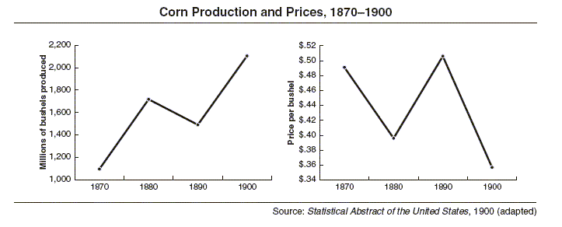
     | 1. | increase in prices paid for farm products
     | 2. | decline in the population growth rate of the United States
     | 3. | decline in demand for agricultural products
     | 4. | increase in the use of farm machinery
     | 1. | western farmers
     | 2. | union leaders
     | 3. | factory owners
     | 4. | railroad owners
     | 1. | increase safety in the workplace
     | 2. | promote fair hiring practices
     | 3. | improve working conditions
     | 4. | protect the interests of small businesses
     | 1. | When production increases, prices decrease.
     | 2. | When production increases, prices increase.
     | 3. | When production remains unchanged, prices decrease.
     | 4. | Prices and production are usually unrelated.

